MINUTES OF A MEETING OF THE FINANCE AND GENERAL PURPOSES COMMITTEE
OF KINVER PARISH COUNCIL HELD AT 95 HIGH STREET, KINVER ON MONDAY 21ST JUNE 2021
_______________________________________________________

Councillors: P Wooddisse (Chairman), JK Hall (ex-officio), I G Sadler (Vice Chairman) , Mrs C Allen, H Williams.

Councillor G Sisley was also in attendance.

Welcomed members to the committee and a vote thanks was expressed for his hard work and diligence.

- APOLOGIES FOR ABSENCE

Councillor BR Edwards was not in attendance.

- DECLARATIONS OF PECUNIARY INTERESTS

None were declared.

- MINUTES OF THE MEETING OF 20TH APRIL 2021

The minutes of the meeting held on 21st April 2021 were approved and signed as a true record of that meeting.

- To review the budget comparison for the period ending 31st May 2021 (figures attached)

The Chairman presented the budget comparison he had prepared for year ended 31st May 2021 as attached as Appendix 1 to these minutes the figures were reviewed and noted.

It was agreed to have a sperate budget line, for the EV income. The Clerk for the next meeting will prepare the income against the cost of electricity.

- To receive formally the accounts for the period from April – May 2021 (figures attached)

The accounts as attached as Appendix 1 to these minutes: the figures were reviewed and noted.

It was Resolved to Recommend to the Parish Council that the accounts up to the 31st May 2021 as set as Appendix 2 to these minutes be accepted. On a vote this was unanimous.

- Items referred from the Parish Council for funding

Replacement bus shelter for Stourton

It was agreed to recommend the Parish Council that a letter is sent to those residents that have expressed their concerns, stating that due to the current Covid restrictions, this should be deferred until the September meeting.

L & A Recommendations from the May that a sum of £250 is requested to purchase native bulbs / plants to be planted in the Autumn.

It was agreed to Recommend too the Parish Council that a sum of £250 is reserved for expenditure for the bulbs / plants. On a vote this was agreed.

To discuss Staffordshire Council DPO service offer this was referred to the Finance Committee.
It was agreed to recommend to the Parish that we do not need this service as we have adequate cover in place.

Requests for Financial Support from Kinver Bowling Club £2500

It was agreed to recommend to the Parish Council that this application is not progressed, due to the Parish Council have a maximum grant of £250 per application.

- To discuss the Van Lease that is due for renewal in November 2021

The Clerk to investigate the cost of purchasing the van from the Lease Company at the end of the term, to progress with Councillor Mrs V Wilson re supplying a used vehicle.

In addition we will explore the cost of a second hand 4 wheel drive pickup.

- Date of Next Meeting – Wednesday 28th July 2021

- Items for future agendas – Fixed assets, accounts for payment,

10. Recommendations to the Parish Council

It was Resolved to Recommend to the Parish Council that

- The accounts up to the 31st May 2021 as set as Appendix 2 to these minutes be accepted.
- Replacement bus shelter for Stourton - a letter is sent to those residents that have expressed their concerns, statin that due to the current Covid restrictions, this should be deferred until the September meeting.
- DPO Service - we do not need this service as we have adequate cover in place.
- Kinver Bowling Club £2500 - this application is not progressed, due to the Parish Council have a maximum grant limit of £250 per application
- To look at costs of buying the existing vehicle from the County at the end of the lease, and investigate other options.
- L & A Bulbs - a sum of £250 is reserved for expenditure for the bulbs / plants.

Appendix 1 to the minutes of the Finance Committee held on the 21st June 2021
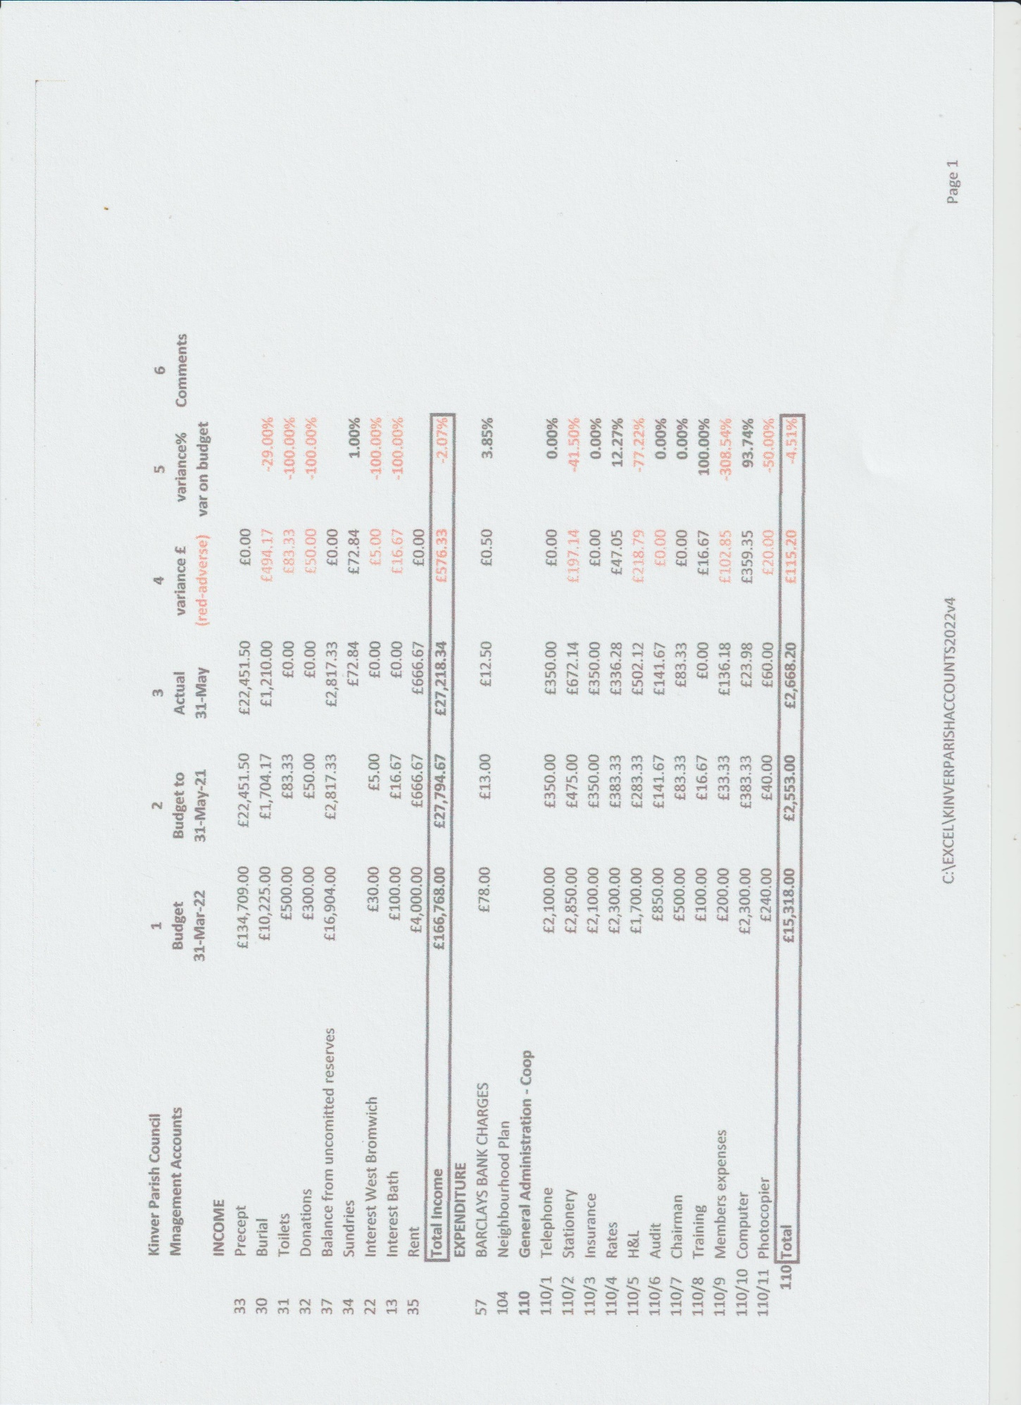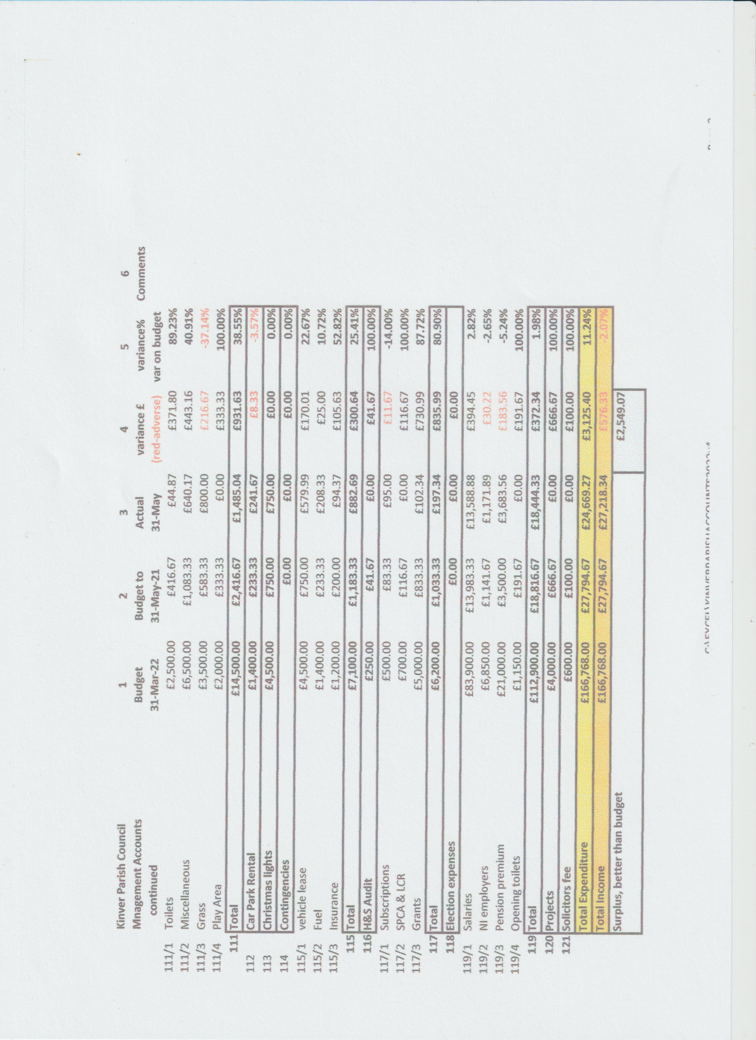

Appendix 2 to the minutes of the Finance Committee held on the 21st June 2021

Financial Summary - Cashbook
Summary between 01/04/21 and 31/05/21 inclusive.
Balances at the start of the year
Ordinary Accounts
.BARCLAYS BANK £904.23
.COOPERATIVE BANK C & I £6,380.50
Bath Building Society £37,626.26
Reserves West Bromwich £44,299.13
Total £89,210.12
RECEIPTS Net Vat Gross
Total Receipts £71,670.42 £0.00 £71,670.42
PAYMENTS Net Vat Gross
Total Payments £24,730.53 £316.81 £25,047.34
Closing Balances
Ordinary Accounts
.BARCLAYS BANK £891.73
.COOPERATIVE BANK C & I £53,016.08
Bath Building Society £37,626.26
Reserves West Bromwich £44,299.13
Total £135,833.20
Signed
Chair Clerk / Responsible Financial Officer
03/06/21 11:26 AM Vs: Kinver Parish Council Page 1

Financial Budget Comparison
Comparison between 01/04/21 and 31/05/21 inclusive.
Excludes transactions with an invoice date prior to 01/04/21
2021/2022 Actual Net Balance Bal %age
INCOME
Council
13 INTEREST BATH BUILDING £100.00 £0.00 -£100.00 -100.00%
SOCIETY
17 PRECEPT £0.00 £0.00 £0.00 0.00%
22 INTEREST WEST BROM £30.00 £0.00 -£30.00 -100.00%
ACCOUNT - CHARITY ACC
30 Burial Fees - Co-Op bank £10,225.00 £1,210.00 -£9,015.00 -88.17%
account
31 Toilet Income - Co-Op bank £500.00 £0.00 -£500.00 -100.00%
account
32 Donations - Co-Op bank £300.00 £0.00 -£300.00 -100.00%
33 Precept - Co-Op Bank Account £134,709.00 £67,354.50 -£67,354.50 -50.00%
34 Sundries - Co-Op Bank Account £0.00 £172.84 £172.84 100.00%
35 Police Office Rent - Co-Op Bank £4,000.00 £0.00 -£4,000.00 -100.00%
Account
37 Balance from uncomitted reserves £16,904.00 £0.00 -£16,904.00 -100.00%
Total Income £166,768.00 £68,737.34 -£98,030.66 -58.78%
EXPENDITURE
Council
57 BARCLAYS BANK CHARGES £78.00 £12.50 £65.50 83.97%
104 NEIGHBOURHOOD PLAN £0.00 £0.00 £0.00 0.00%
110 General Administration - Co-Op
Bank Account
110/1 Telephone £2,100.00 £0.00 £2,100.00 100.00%
110/2 Stationary £2,850.00 £772.14 £2,077.86 72.91%
110/3 General Insurance £2,100.00 £0.00 £2,100.00 100.00%
110/4 Rates £2,300.00 £336.28 £1,963.72 85.38%
110/5 Office Electricity and Gas £1,700.00 £379.44 £1,320.56 77.68%
110/6 Audit £850.00 £475.00 £375.00 44.12%
110/7 Chairmans Allowance £500.00 £0.00 £500.00 100.00%
110/8 Staffing Training Expenses £100.00 £0.00 £100.00 100.00%
110/9 Members Expenses £200.00 £136.18 £63.82 31.91%
110/10 Computer Support Services £2,300.00 £23.98 £2,276.02 98.96%
110/11 Photocopier £240.00 £60.00 £180.00 75.00%
110 Total £15,240.00 £2,183.02 £13,056.98 85.68%
111 Maintenance - Co-Op Bank
Account
111/1 Maintenance Toilets £2,500.00 £44.87 £2,455.13 98.21%
111/2 Maintenance Misc £6,500.00 £640.17 £5,859.83 90.15%
111/3 Grass Cutting £3,500.00 £800.00 £2,700.00 77.14%
111/4 Play Area £2,000.00 £0.00 £2,000.00 100.00%
111 Total £14,500.00 £1,485.04 £13,014.96 89.76%
112 Car Park Rental - Co-Op Bank £1,400.00 £1,450.00 -£50.00 -3.57%
Account
113 Christmas Illuminations - Co-Op £4,500.00 £70.93 £4,429.07 98.42%
Bank Account
114 Contingencies - Co-Op Bank £0.00 £0.00 £0.00 0.00%
Account

Financial Budget Comparison
Comparison between 01/04/21 and 31/05/21 inclusive.
Excludes transactions with an invoice date prior to 01/04/21
2021/2022 Actual Net Balance Bal %age
115 Vehicles - C0- Op Bank Account
115/1 Leasing £4,500.00 £0.00 £4,500.00 100.00%
115/2 Fuel £1,400.00 £208.33 £1,191.67 85.12%
115/3 Insurance £1,200.00 £94.37 £1,105.63 92.14%
115 Total £7,100.00 £302.70 £6,797.30 95.74%
116 Health and Safety - Co-Op Bank £250.00 £0.00 £250.00 100.00%
Account
117 Grans Subs Co-Op Bank Account
117/1 Parish Councils Subs £500.00 £95.00 £405.00 81.00%
117/2 SPCA / LCR £700.00 £0.00 £700.00 100.00%
117/3 Grants £5,000.00 £102.34 £4,897.66 97.95%
117 Total £6,200.00 £197.34 £6,002.66 96.82%
118 Election Expenses - Co-Op Bank £0.00 £0.00 £0.00 0.00%
Account
119 Wages/Salaries - Co-Op Bank
Account
119/1 Salaries £83,900.00 £13,588.88 £70,311.12 83.80%
119/2 Employers NI £6,850.00 £1,171.89 £5,678.11 82.89%
119/3 Employers Pension £21,000.00 £3,683.56 £17,316.44 82.46%
119/4 Toilets £1,150.00 £0.00 £1,150.00 100.00%
119 Total £112,900.00 £18,444.33 £94,455.67 83.66%
120 Community Projects - Co-Op £4,000.00 £0.00 £4,000.00 100.00%
Bank Account
121 Legal Fees - Co-Op Bank Account £600.00 £0.00 £600.00 100.00%
Total Expenditure £166,768.00 £24,145.86 £142,622.14 85.52%
Total Income £166,768.00 £68,737.34 -£98,030.66 -58.78%
Total Expenditure £166,768.00 £24,145.86 £142,622.14 -85.52%
Total Net Balance £0.00 £44,591.48
03/06/21 11:36 AM Vs: Kinver Parish Council Page 2

