MINUTES OF THE PLANNING AND DEVELOPMENT COMMITTEE MEETING HELD ON THE 12th JUNE 2020 AT 95 HIGH STREET, KINVER.
______________________________________________________________________________

Present: Councillors: Mrs C Allen (Chairman), P Wooddisse, G Sisley, E Simons, JK Hall (Vice Chairman), S Anderson, Mrs E Lord and Miss V Webb.

1. APOLOGIES FOR ABSENCE

No apologies were received.

2. DECLARATIONS OF PECUNIARY INTEREST

Councillor Mrs C Allen declared a non-pecuniary interest in planning application 20/00371/ful.

3. MINUTES OF THE PREVIOUS MEETING

The minutes of the meeting held on 26th February 2020 were approved and signed as a true record of the proceedings of that meeting.

4. MATTERS ARISING FROM PREVIOUS MINUTES

20/00008/FUL Weatheroaks, Lawnswood
The development of a new residential home, using part of the existing plot and creating a new plot, plans include, detached garage for existing property, demolition of existing garage and annexe, construction of a detached double garage for new 5 bed property

Previous Recommend Refusal on the grounds that:
The development would be damaging to the street scene.
There could be possible damage to the surrounding trees and this should be referred to Steve Dores.
Its contrary to Greenbelt policies - EQ4 - Protecting and enhancing the area, EQ9 - Protecting Residential Amenity, EQ11 Wider design considerations.
The scale, design and mass, it is detrimental to the surroundings.
There is no landscaping to the whole front of the building and this is contry to policy EQ1.

The following comments were made and noted:-

- Comments from Severn Trent -
Severn Trent Water advise that there may be a public sewer located within the application site. Although our statutory sewer records do not show any public sewers within the area you have specified, there may be sewers that have been recently adopted under the Transfer Of Sewer Regulations 2011. Public sewers have statutory protection and may not be built close to, directly over or be diverted without consent and contact must be made with Severn Trent Water to discuss the proposals. Severn Trent will seek to assist in obtaining a solution which protects both the public sewer and the building. Please note that there is no guarantee that you will be able to build over or close to any Severn Trent sewers, and where diversion is required there is no guarantee that you will be able to undertake those works on a self-lay basis. Every approach to build near to or divert our assets has to be assessed on its own merit and the decision of what is or isn't permissible is taken based on the risk to the asset and the wider catchment it serves. It is vital therefore that you contact us at the earliest opportunity to discuss the implications of our assets crossing your site. Failure to do so could significantly affect the costs and timescales of your project if it transpires diversionary works need to be carried out by Severn Trent.

With this in mind and all the neighbours complaining that the planned garage on the left hand side of the original house is going to be built over the main sewer which feeds not only Lawnswood Drive, but Hunters Rise as well, this should surely be Rejected because of the implications.

- The three trees in the garage area all have TPO's on them. The preservation order number from 1979 are in brackets. In the plans they are known as T2 (T13) - Oak, T3 (T16) - Silver birch belonging to the neighbour and T4 (T14) - an older Oak.
Steve Dores initially got muddled with these and has since retracted his statement to say he has no objection and will look into the tree numbering and positioning again. It is quite clear from the evidence I have seen that all three trees have TPO's on them and should not be touched. T2 (T13), T3 (T16) and T4 (T14).

- The new garage and carport still we feel would damage the roots of all three trees. From photos taken it is clear that the so called existing garage (a wooden shed) would need new foundations. The thin concrete layer would not support a brick and tiled garage. If they only built on the existing foundations the inside part , due to the brickwork, would be even smaller which in turn would be unable to house a modern car.

The carport is built around T2. How will they accommodate the ever growing girth of the tree? In my photos you can see there is a gap between the 'garage' base and the second smaller base that the trailer on. How will it be possible not to disturb and to protect the roots of T2 with a new base?

- The garage is right on the roadside, thus making it very difficult for people pulling off the neighbours drive at 'Chadwick' as it blocks the view up the road to see oncoming traffic. The leg of the new carport would block the only view they have looking up the road, before getting to the junction.

- The design and access statement has some inaccuracies. 4.1.1 talks about tree T5 and the impact of the garage on its root system. T5 is the opposite side of the neighbours drive. T2 is the tree that will be majorly impacted. This tree is not mentioned in the 'foundations' paragraph.

- Tree pruning 4.1.5
Because of the mix up Steve Dores has had over which tree is which, T4 had already had the lower branches removed up to at least 10m and thankfully was stopped by the neighbours and not felled completely.

- Windows to the side of the proposed property.
There are windows on the first floor and 1 window on the second floor all overlooking the neighbours land. His grandchildren often play in that area and they are worried about them being so overlooked. In the planning regs side windows should had obscure glass and non-opening windows. This should be the case here.

- The design and access statement is to the most part null and void as it refers to the previous design.

With these additional comments plus are previous comments we still propose to reject the application. Photos are attached as appendix 1 to these minutes.

5. TO RATIFY THE RECOMMENDATIONS SENT IN MARCH / APRIL AND MAY

The recommendations are set out as appendix 2 to these minutes.

It was agreed to recommend to the Parish Council that these be agreed due to the time limits.

6. PLANNING APPLICATIONS

20/00371/FUL Pine Croft, 7 Chantry Road, Stourton
Single storey side extension to the principal elevation, constructing an entrance porch and extending the bay window / front room to line up with existing canopy soffit.

Recommend Approval

20/00376/FUL Mile Flat House, Mile Flat
2 storey side extension and single storey rear extension

Recommend Approval but we ask that the District Council seek advice from the County Archaeologist as the site is near an Ancient Monument.

20/00364/FUL Stourton Court, Bridgnorth Road
Creation of one additional flat and regularisation of unauthorised works

Recommend Refusal on the grounds that the plans are unclear and do not show any details of the proposed additional flat. Materials to be used should be detailed. We would request a full breakdown of what is being planned, what materials are to be used so we can see the full extent of the development.

20/00270/FUL Potters Cross Post Office, White Hill, Kinver
Retrospective application for decking

Recommend Approval

20/00382/FUL 177 Enville Road, Kinver
Proposed detached vehicle garage structure

Recommend Refusal on the grounds that if the existing fence is removed then cars will reverse possibly into the path of the pedestrians using this very well used public footpath.

If this application is approved then a section 106 should be put on the development stating that the verge used for access should be made good and tarmaced and maintained by the owner.

20/00406/FUL The Paddocks, Mile Flat, Greensforge
2 no proposed replacement house types

Defer to the next meeting

7 PLANNING DECISIONS REACHED BY SOUTH STAFFORDSHIRE DISTRICT COUNCIL

The Planning decisions are set out as appendix 3 to these minutes.

- TO DISCUSS THE BENEFITS OF UNDERTAKING A NEIGHBOURHOOD PLAN FOR THE PARISH

A discussion took place with Kelly Harris about the new SAD and Neighbourhood plans, and other type of proposals.

Concern was expressed over using other areas of the Parish not just the centre of the village.

Growth areas should be identified by the Parish to be considered for future development.

Infrastructure is also key to the development.

Councillor Mrs E Lord reported that Codsall PC who have recently started a Neighbourhood Plan were very positive, stating that they felt it would help them to direct where housing went, and plan infrastructure. There was also the potential for a greater proportion of CIL money from developments, if SSDC were to charge that levy.

The Plan would help with these and help steer new developments in a way we want our parish to be developed. Cost is approx. £20,000 and grants to cover the substantial cost are available. Members and the Clerk will look into options for possible consultants to help with the process.

It was proposed to the Parish Council that a Neighbourhood Plan is progressed forward, and approx. costs to be brought forward when it is discussed.

On a vote this was carried.

- ITEMS FOR FUTURE AGENDA

Clarification on funds for community use from the Hyde Lane development.

- DATE OF NEXT MEETING

The date of the next meeting was noted as tbc.

- RECOMMENDATIONS TO THE PARISH COUNCIL

The following recommendations were put to the Parish Council next meeting that:-

- the planning recommendations as set out in agenda item 6 are agreed and have been sent to the District Council due to the time constraints.
- the previous recommendations under item 5 are agreed.
- a Neighbourhood Plan is progressed forward, and approx. costs to be brought forward when it is discussed.

Appendix 1 to the minutes of the Planning and Development Committee held on the 12th June 2020

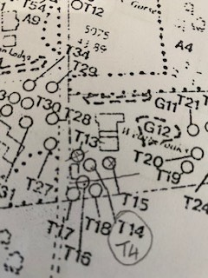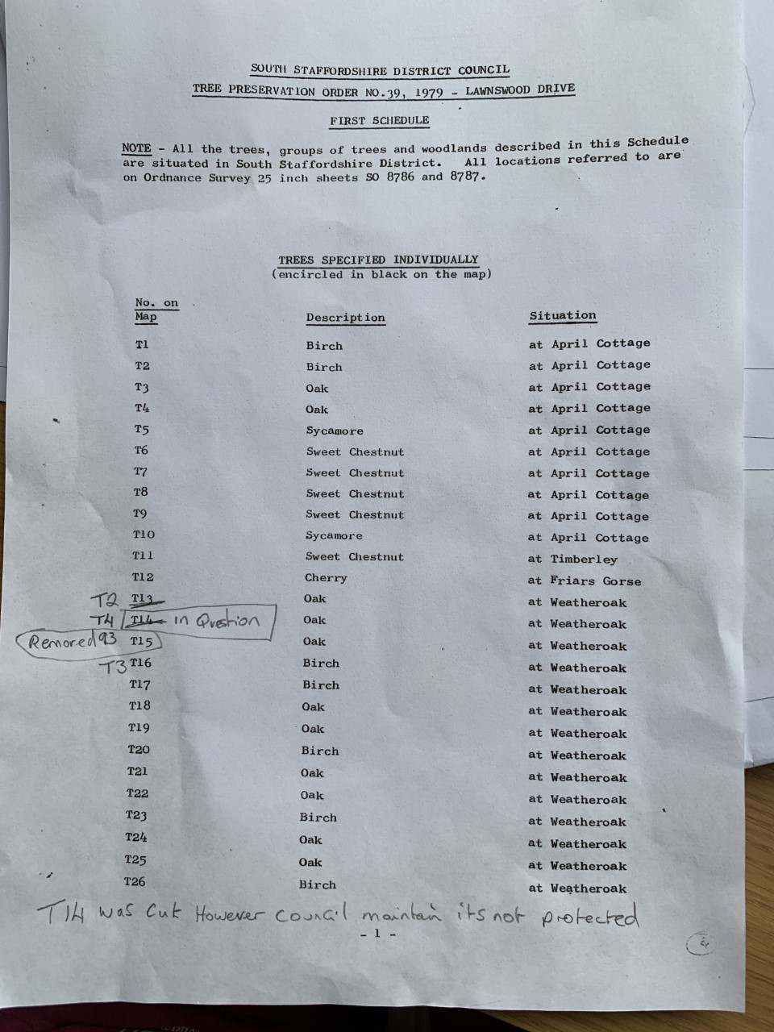

Appendix 2 to the minutes of the Planning and Development Committee held on the 12th June 2020

20/00044/COU 7 High Street
Recommend Refusal on the grounds that the premises are outside the commercial core of the High Street.
The frontage as shown would change the character, especially as the building is so close to some of the most historic and attractive buildings in the High Street.
As a Parish we feel that we need houses more than new yoga studios and there are vacant commercial premises nearby which would be far better used for this purpose. Although the address is on the High Street, it is surrounded by residential properties and offers no parking for customers and clients.

If this application is approved then conditions need to be placed on the applications to ensure that running arrangements and appearance are not detrimental to the surrounding area.

20/00008/FUL Lawnswood Drive (PreApp 19/00033)

Recommend Refusal on the grounds that:
The development would be damaging to the street scene.
There could be possible damage to the surrounding trees and this should be referred to Steve Dores.
Its contrary to Greenbelt policies - EQ4 - Protecting and enhancing the area, EQ9 - Protecting Residential Amenity, EQ11 Wider design considerations.
The scale, design and mass, it is detrimental to the surroundings.
There is no landscaping to the whole front of the building and this is contry to policy EQ1.

20/00314/COU Sugarloaf Lane, Iverley
Recommend Approval as the land should remain in the ownership of Highways.

Tree application
No objection refer to Steve Dores

20/00347/FUL 167 Enville Road
No objections.

20/00043/FUL KSCA, Legion Drive, Kinver
Creation of new entrance and toilet extension, re-roofing with rear terrace with internal alterations
Recommend Approval but in view of the location, and the increased risk of flooding due to climate change, we recommend that design and construction take into due account ensuring resilience of the building against flooding.

20/00232/FUL 8 Roundhill Farm Cottages, Whittington Hall Lane, Kinver
Extensions to provide accommodation for elderly family members and improved accommodation to main family home
Recommend Approval

20/00271/FUL Beauchamp House, Wolverhampton Road, Stourton
Resubmission of planning application 19/00739/FUL, revision to external appearance of the finishes and pitch of the roof.
Recommend Approval

20/00245/FUL 116 High Street Kinver
Replacement of 11 windows Location:
Recommend Approval subject to the Conservations Officers approval

20/00152/FUL Post House Bridgnorth Road Stourton
Installation of Bio-Pure 2 (1 - 7 person) sewage treatment system to replace a septic tank
Recommend Approval

Appendix 3 to the minutes of the Planning and Development Committee held on the 12th June 2020

Application Number Description SSDC KPC

20/00107/FUL 24 Greensforge Lane, Stourton App. Rec App.
2 storey side extension over garage
20/00066/FUL Rosemary Cottage, 4 James Street, Kinver App. Rec App.
Proposed alterations to existing dormer windows
19/00978/FUL Brewtopia, Church Hill, The Compa, Kinver App.
Lawful siting of 2 new timber buildings and the change
of use of agricultural land to garden land
19/00973/FUL Land adjacent to 26 Dark Lane, Kinver Ref. Rec Ref.
New dwelling
19/00856/FUL Land at rear of 47 High Street, Kinver App. Rec Ref.
New Oak framed dwelling
19/00709/FUL Kinver High School, Kinver App. Rec App.
Demolition of sports hall and construction of new 4
court sports hall with ancillary accommodation of
external courts, car parking and reinstatement
18/00092/FUL The Royal British Legion, High Street, Kinver App. Rec Ref.
Demolition of derelict former social club, construction of
new residential apartment block
20/00004/VAR Land at the Burgesses, Kinver App.
Request that condition 4 of approval 18/00322/FUL
19/00911/FUL 177 Enville Road, Kinver App. Rec Ref.
Proposed demolition of existing ground floor extension,
forming a new ground and first floor layouts to enable
the erection of a new attached 2 story end Terrace dwelling
19/00866/FUL 43 Stone Lane Kinver App. Rec App.
Ground floor rear extension (measuring: depth 7 metres,
eaves height 2.9 metres, maximum height 4.0 metres)
19/00915/FUL 13 Chantry Road New Wood App Rec App.
Single storey rear and side extension
19/00935/FUL Land at Norton Road, Iverley Ref. Rec Ref.
Construction of 1 no dwelling
20/00020/FUL Covert Cottage, Norton Road, Iverley App. Rec App.
Single storey rear extension loft conversion. Detached garage

20/00271/FUL Beauchamp House Wolverhampton Road Prestwood App. Rec App.
Resubmission of planning application 19/00739/FUL showing
revision to external appearance of the finishes and pitch of roof
20/00232/FUL 8 Round Hill Farm Cottages Whittington Hall Lane Kinver App. Rec App.
Extension to provide living accommodation for elderly family
members and improved accommodation to main family home
20/00314/COU Glenhaven Sugarloaf Lane Iverley App. Rec Ref.
Change of use from public highway to private land

